SB GAK Website Data
- Senior Boys School
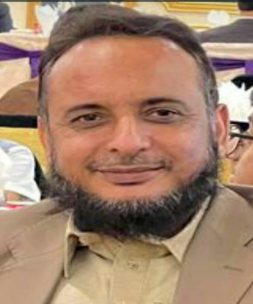

Acting Sec Head
Mr Atiq ur Rehman
- MA (Isl & Pol Sci), B.Ed
- 5th Jan 1998

Short message:
Welcome to the Senior Boys Section
Where ambition meets excellence, and today’s learners become tomorrow’s leaders.
These defining years are where passion turns into purpose and dreams take shape. In the Senior Boys Section, we don't just prepare our students for exams—we prepare them for life. We challenge our young men to think critically, lead with integrity, and embrace every opportunity with confidence.
Aim high, work hard, and step boldly into your future. We are here to guide and support you every step of the way!

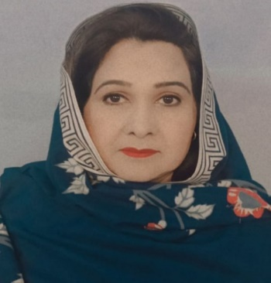
Deputy Sec Head
Mrs Nabeela Asif
- MA Urdu Lit, M.A. Ed
- 18th August 1997
- English Department
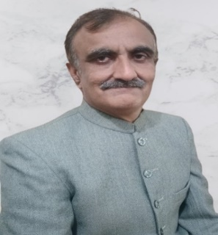
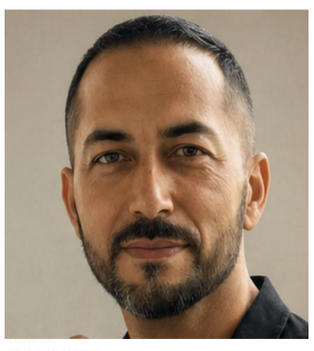
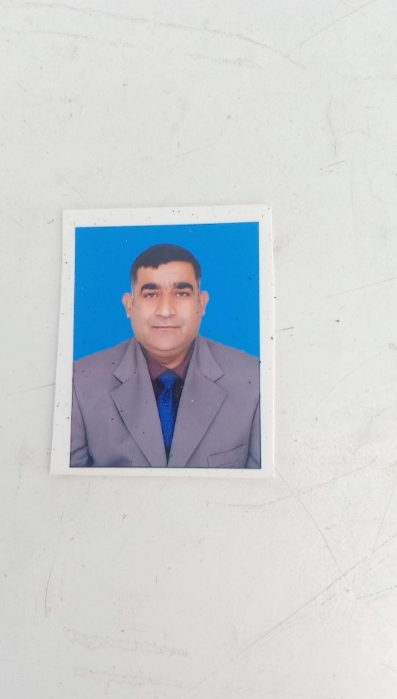

Mr Shakeel Ahmed
(Teacher)
- MA Eng, B. Com
- 1st September 2006
Mr Zeeshan Imtiaz
(Teacher)
- MA (English)
- 21st November 2022
Mr. Ahmed Masood
Sadiq
(Subj. Coord - English)
- MA (English)
- 24th August 2012

- Islamiyat Department
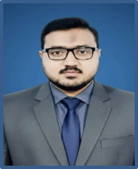
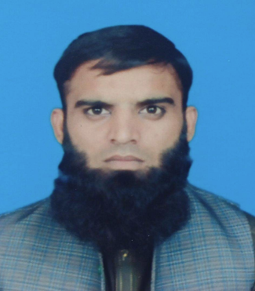

Mr Muhammad Haseeb Ullah
(Teacher)
- BS (Isl)
- 26th August 2025
Mr Usama Sajjad
(Teacher)
- MA Islamic Std, BS (Mass Comm),
- 12th February 2025

- Urdu Department

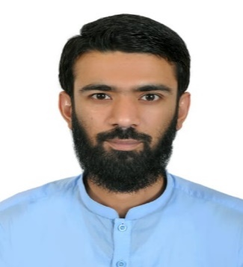
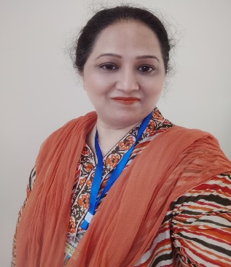
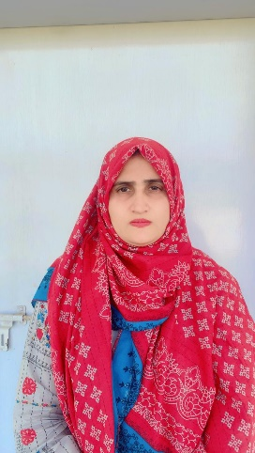

Mrs Adeela Ather
(Teacher)
- MA (Urdu)
- 14th September 2014
Mrs Massarat Naseem
(Subj. Coord.)
- MA Urdu), B.Ed
- 12th February 2025
Mr Wasif Raheem
(Teacher)
- MA Urdu, MA History, M. Phil Urdu (Cont)
- 12th February 2025

- Maths Department
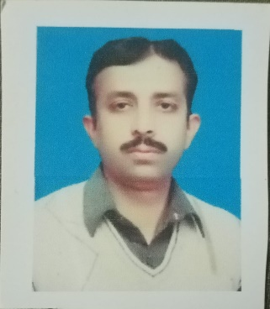
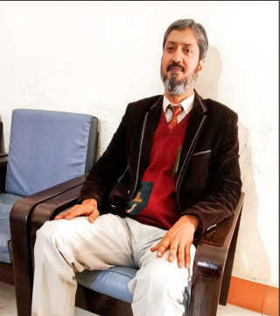


Mr Sohail Ahmed Tahir
(Subj. Coord)
- MSc (Math),M.Ed
- 19th July 2016
Mr Mudassar Nisar
(Teacher)
- MCS
- 16th August 2002
Mr Abdul Jabbar
(Teacher)
- MSC Maths
- 27th August 2024

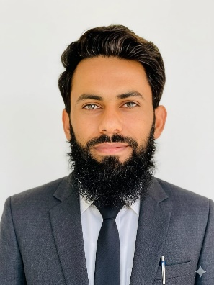
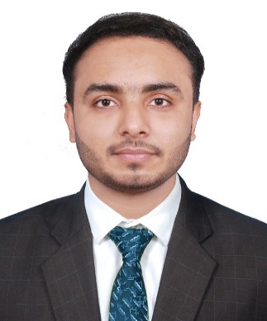

s

Mr Shehroze Saeed
(Teacher)
- BS Mathematics
- 1st July 2026
Mr Waseem Munawar
(Teacher)
- M.Phil Mathematics
- 4th October 2024

- Physics Department
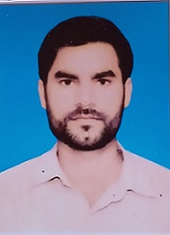
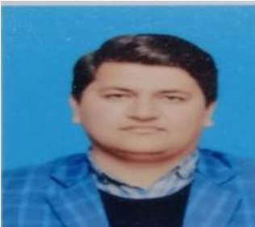
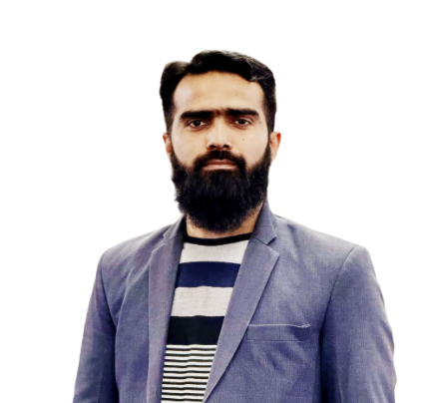

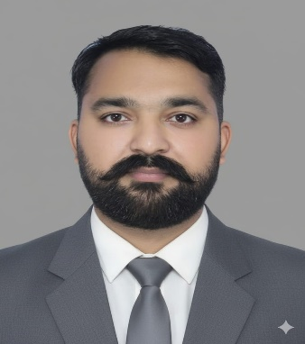
Mr Saqib Ali
(Teacher)
- MSc (Phy)
- 6th January 2020
Mr Umer Ashfaq
(Teacher)
- MSc (Phy)
- 28th August 2017
Mr Sohaib Hameed Butt
(Teacher)
- M. Phil (Phy)
- 26th August 2021
Mr Bilal Younis
(Subj. Coord.)
- MSc (Phy)
- 26th August 2021

- Chemistry Department

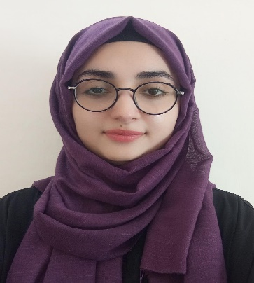
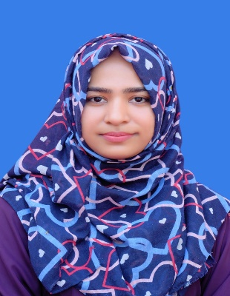
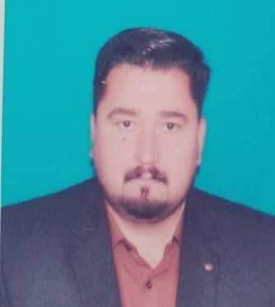

Ms Zubia Ifrahim
(Teacher)
- Mphil Chemistry
- 3rd August 2026
Mr Nasar Hussain
(Subj. Coord.)
- MSc (Phy)
- 26th August 2021
Ms Lubaba Ayaz Balor
(Teacher)
- MSc (Phy)
- 28th August 2017

- Computer Department
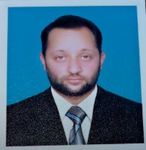
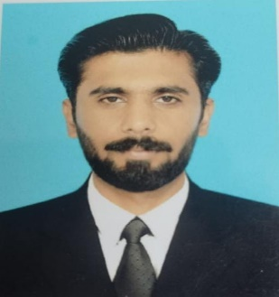
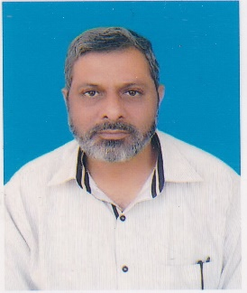

Mr Talha Asif
(Teacher)
- BSCS
- 01-Aug-26
Mr Shaban Bin Akhtar
(Teacher)
- M. Phil (CS)
- 27-Nov-23
Mr Tauqeer Shafi
(Subj.Coord)
- BCS (Comp)
- 7-Feb-2000

- Biology Department
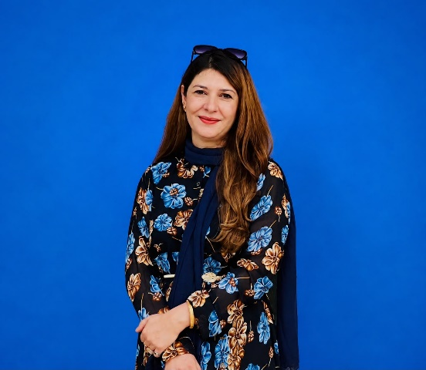
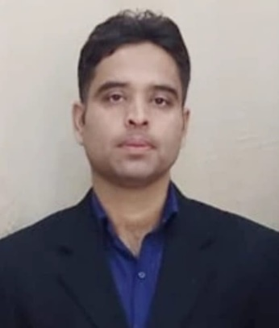

Mr Mehwish Jadoon
(Subj. Coord.)
- PhD in Clinical Medical Biochemistry, M.Phil Bio Chem, CHPE (NUMS)
- 1-Oct-25
Mr Usman Ahsan
(Biology)
- MSc (Bot),MA Pol Sci
- 15-Aug-24

- Pak Studies Department



Mr Hafiz Atta Ul Munim Bukhari
(Subj. Coord.)
- MA History
- 02-May-25

APSACS Academic Schedule Class IX-X
Date | Class IX | X
2nd, 3rd April, 2026 | Teacher’s Preparation Days | ---
28th, 29thApril, 2026 | --- | Teacher’s Preparation Days
4th May, 2026 | Orientation Day for Parents | ---
6th May, 2026 | New Academic Session Begins | ---
11th - 20th May, 2026 | Class Assessment I | ---
25th – 29th May, 2027 | Eid ul Azha Holidays
6th June, 2026 | PTM & Result | ---
15th June – 12th July 2026 | Summer Vacations
13th July 2026 | School Reopens after Summer Vacations
27th July – 5th August 2026 | Class Assessment II | Class Assessment I
22nd August 2026 | PTM & Result | PTM & Result
7th – 16th September, 2026 | Class Assessment III | Class Assessment II
26th September, 2026 | PTM & Result | PTM & Result
1st October -20th October,2026 | Revision& Test Series
23rd October – 7th November, 2026 | First Term Examination
10th November, 2026 | Second Term Begins
14th November, 2026 | PTM & Result
28th December, 2026 – 10th January 2027 | Winter Break
11th January, 2027 | School Reopens after Winter Break
18th January – 4th February, 2027 | Revision & Test Series
8th – 20th February, 2027 | Pre Board Examination
22nd – 26th February 2027 | Result Preparation Days
22nd – 12th March, 2027 | Prep Leave for FBISE Examinations
27th February, 2027 | PTM & Result
10th – 12th March, 2027 | Eid ul Fitr Holidays
17thMarch, 2027 | FBISE Examination (Tentative)

APSACS Academic Calendar Class XI-XII
Date | Class XI - XII
16th, 17th July, 2026 | Teacher’s Preparation Day
18th July, 2026 | Orientation Day for Parents (only XI)
20th July, 2026 | New Academic Session Begins
31st August - 8th September, 2026 | Class Assessment I
12th September, 2026 | PTM & Result
19th – 27th October, 2026 | Class Assessment II
31st October, 2026 | PTM & Result
30th November – 4th December 2026 | Revision& Test Series
7th – 18th December, 2026 | 1st Term Examination
21st December, 2026 | 2nd Term Begins
24th December, 2026 | PTM & Result
28th December, 2026 – 10th January, 2027 | Winter Break
11th January, 2027 | School Reopens
22nd February – 9th March, 2027 | Revision & Test Series
10th – 12th March, 2027 | Eid ul Fitr Holidays
15th – 26th March, 2027 | Preboard Examination
29th March – 2nd April, 2027 | Result Preparation Days
29th March – 18th April, 2027 | Prep Leave for FBISE Examinations
3rd April, 2027 | PTM & Result
19th April, 2027 | FBISE Examination (Tentative)

CCA Activities
Date | Class IX |  | Class X
22th April, 2026 | Investiture Ceremony |  | ---
1st May, 2026 | Labor Day |  | ---
6th May, 2026 | Contagious Disease Awareness Day
10th May, 2026 | Youm-e-Marka-e-Haq
15th – 16th May, 2026 | Literature Festival
20th May, 2026 | --- | Investiture Ceremony
18th – 22nd May, 2026 | SDGs Awareness Week
20th May, 2026 | Youm-e-Takbeer
24-25th June,26 Ashura | 24-25th June,26 Ashura
5th August 2026 | Investiture Ceremony
12th August, 2026 | International Youth Day
14th August, 2026 | Independence Day
21st – 22nd August 2026 | Literature Festival
25th August, 2026 | 12 Rabi ul Awal
6th September, 2026 | Defense Day / Youm e Shuhada
8th September, 2026 | International Literacy Day
21st September, 2026 | International Peace Day
28th September – 3rd October, 2026 | Intra-Regional Sports Competition (G-III)
30th September, 2026 | Mega Naat & Qirat Competition
3rd October, 2026 | APSACS Foundation Day
5th October, 2026 | World Teachers Day
7th October, 2026 | Parliamentary Style Debate
10th October, 2026 | World Mental Health Day
15th October, 2026 | Anti-Drug Awareness Day
9th November, 2026 | Iqbal Day
16th November, 2026 | International Day of Tolerance
16th – 21st November, 2026 | Inter Zonal Sports Competition
23rd – 27th November, 2026 | Civic Awareness and Community Service Week
1st – 4th December, 2026 | Science & Technology Week
3rd December, 2026 | International Day of Persons with Disabilities
11th – 13th December, 2026 | AMUN
16th December, 2026 | Youm-e-Qoumi Azm-e-Taleem
25th December, 2026 | Quaid’s Day
11th – 16th January, 2027 | APSACS Sports Championship (G III)
5th February. 2027 | Kashmir Day

Date | CCA Plan
29th July, 2026 | Contagious Disease Awareness Day
5th August, 2026 | Investiture Ceremony
12th August, 2026 | International Youth Day
14th August 2026 | Independence Day
21st – 22nd August, 2026 | Literature Festival
24th – 28th August, 2026 | SDGs Awareness Week
25th August, 2026 | 12 Rabi ul Awal
6th September, 2026 | Defense Day / Youm e Shuhada
8th September, 2026 | International Literacy Day
21st September, 2026 | International Peace Day
28th September – 3rd October, 2026 | Intra-Regional Sports Competition (G-III)
30th September, 2026 | Mega Naat & Qirat Competition
3rd October, 2026 | APSACS Foundation Day
5th October 2026 | World Teachers Day
7th October, 2026 | Parliamentary Style Debate
10th October 2026 | World Mental Health
15th October, 2026 | Anti-Drug Awareness Day
9th November, 2026 | Iqbal Day
16th November, 2026 | International Day of Tolerance
16th – 21st November, 2026 | Inter Zonal Sports Competition
23rd – 27th November, 2026 | Civic Awareness and Community Service Week
3rd December, 2026 | International Day of Persons with Disabilities
11th -13th December, 2026 | Youm-e-Qoumi Azm-e-Taleem
16th December,2026 | Quaid day
11th – 16th January, 2027 | APSACS Sports Championship (G-III)
29th – 31st January, 2027 | AMUN
5th February, 2027 | Kashmir Day
8th – 12th February, 2027 | Science & Tech Week
23rd March, 2027 | Pakistan Day

Facilities
Senior Boys Wing Facilities
Our Senior Boys Wing offers an invigorating, secure, and student-focused academic environment engineered to cultivate scholastic distinction and comprehensive personal growth.
Core Campus Features
- Fourteen Modern Classrooms: Expansive learning spaces fitted with ergonomic furnishings, optimal ventilation, and contemporary instructional technologies to foster an immersive educational experience.
- Dedicated Information & Communication Technology (ICT) Lab: A fully equipped computer laboratory designed to advance digital proficiency, technical fluency, and modern research capabilities.
- Advanced Science Laboratories: Cutting-edge facilities tailored for sophisticated practical experimentation, scientific inquiry, and experiential learning.
- Extensive Athletic Grounds: A spacious sports complex dedicated to physical education, athletic training, and recreational initiatives that promote leadership, physical fitness, and camaraderie.
- Chilled Hydration Stations: Purified cold-water dispensers strategically positioned throughout the facility to ensure continuous access to clean drinking water.
- Distinguished Faculty: A highly qualified and seasoned instructional staff dedicated to driving academic rigor through modern pedagogical approaches and personalized mentorship.
- Interactive Academic Culture: A collaborative learning atmosphere structured to enhance analytical reasoning, creative problem-solving, and active intellectual engagement.
- Rigorous Evaluation Framework: A systematic assessment model designed to track academic trajectory, measure competencies, and deliver actionable performance insight.
- Secure & Disciplined Environment: A well-monitored campus infrastructure enforcing strict safety protocols to guarantee a secure learning environment.
- Enriched Co-Curricular Program: Comprehensive opportunities in public speaking, academic competitions, STEM exhibitions, and cultural leadership activities designed to build confidence and resilience.
- Ethical & Character Development: Values-based education integrated into the core curriculum to instill integrity, civic responsibility, and moral leadership.
- Academic & Career Counseling: Specialized guidance services assisting students in evaluating career trajectories, academic pathways, and higher education prospects.
- Sanitary & Well-Maintained Infrastructure: A pristine campus environment prioritizing high hygiene standards across all physical facilities, common areas, and specialized spaces.

